PRUEBA SABER 11

PARTE 4

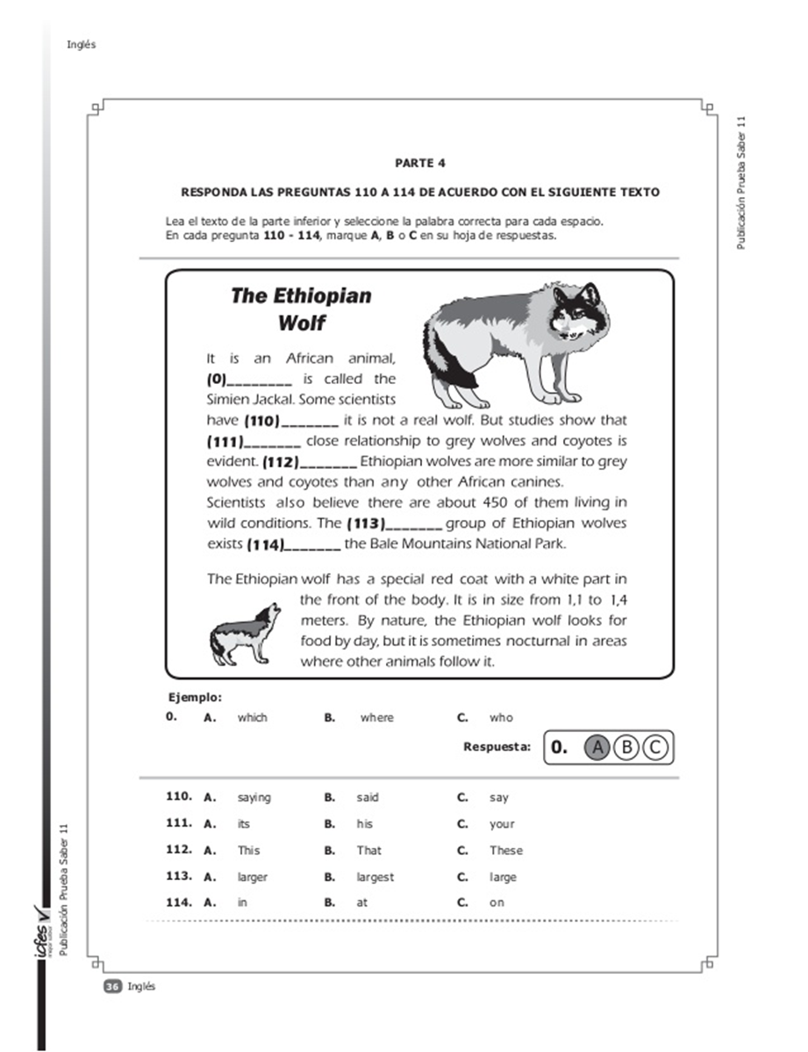

110:B. Said

111:A. Its

112:C. These

113:B. Largest

114:A. In

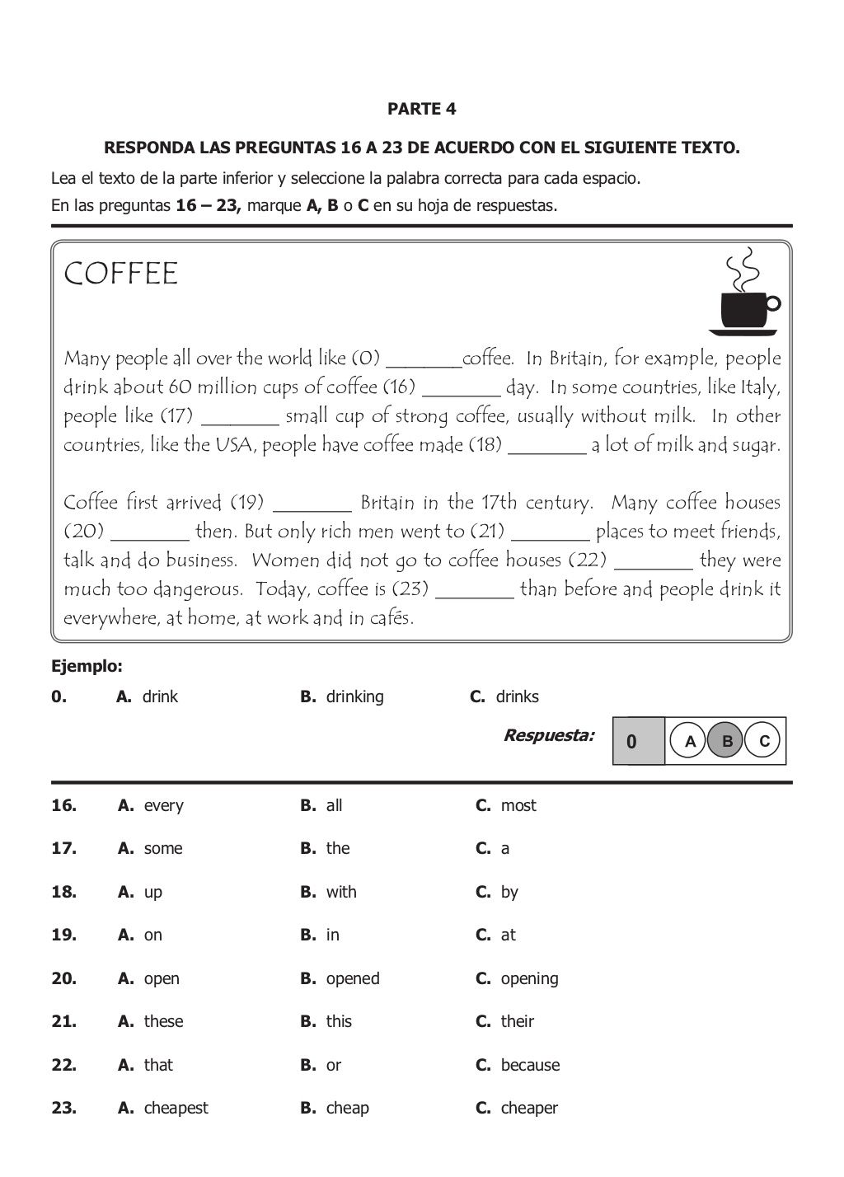

* 16: A. every
* 17: C. a
* 18: B. With
* 19: A. on
* 20: C. opening
* 21: B. This
* 22: C. because
* 23: C. cheaper

NIKOL SERNA 1102